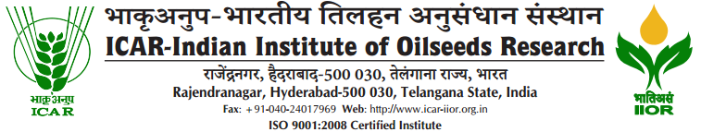

F.No. 5-51/2018/FLD/Estt. Date:07-05-2024
WALK IN INTERVIEW
Eligible candidates are invited to attend Walk in Interview to fill up the temporary post of Young Professional -I (One) under “FLDs on Oilseeds and other extension activities” to be held on 28-05-2024 at 11.00 AM at ICAR – Indian Institute of Oilseeds Research, Rajendranagar, Hyderabad. The requirement and other terms and conditions for Young Professional-I are as under :-

Name of the post | Essential qualifications | Desirable qualifications | Emoluments  (Fixed per month)
Young Professional - I  (ONE) | Bachelor’s degree in statistics/ social science/ any other discipline / PG Diploma in Sustainable agricultural development / Diploma in Agriculture | 1.Working knowledge of computers  2.Experience in field data collection, analysis and working in FLDs related projects  3.The candidate should be able to read, write and speak in Telugu and English | Rs.30,000/- (Consolidated)
Terms and conditions:-
1. Place of posting is ICAR - IIOR, Hyderabad. Work place may be at any place in Telangana
2. All the above engagement is temporary / contractual and carries no other allowances.
3. Contractual appointment are for a specific and co terminus with the project on even before on the discretion of the competent authority. The YP I will have no right to claim any employment or engagement in IIOR.
4. The above position do not have status of regular employees they are not entitled for any regular leave except 8 days CL and 2 days RH, mandatory / paternity leave as applicable.
5. Age limit as on 28.05.2024: Minimum of 21 years and maximum age limit is 35 years for men and 40 years for women as per rules. Relaxation in upper age limit is permissible in case of SC/ST/OBC/PH candidates as per Govt. of India Rules applicable to the external funded project.
6. No TA/DA and official accommodation will be provided for appearing in the Walk in Interview. Selected candidates have to make their own arrangement to stay at the place of work.
7. Candidates are requested to carry all original relevant documents/ certificates along with a set of attested photocopies, photograph and duly filled in application form on the date of interview. They may attend the interview only if they fulfill the essential as well as the desired qualifications.
8. Candidates may register their candidature from 9.30 a.m. to 10.30 am only on 28.05.2024.
9. The Director, ICAR-IIOR, Hyderabad reserves the right to fill up or not to fill any vacancy notified in this advertisement.

PS & PI OF THE PROJECT

